**Recursion Theory**

<https://youtu.be/rf6uf3jNjbo?si=TGokW4ZrmhkaP_Kf>

All Time “**Top Down Approach(Big Problem theke Reverse kore kore Choto Problem ee ashar chinta korbo)**” ee Chinta korbo… mane… f(n) theke f(1) te Top Down Approach ee chinta korbo…f(n) huile Big Problem… arr f(1) huilo BASE Case

Let ***f(n)*** be a recursive function…

1. Show ***f(1)*** works (base case)
2. Assume ***f(n-1)*** works → Very Important Step for ME(Akash) to Remember… This Step is also Called… Recursive LEAP of FAITH… jey ***f(n-1)*** will work
3. Show ***f(n)*** works using ***f(n-1) →*** defining the Relationship between f(n) & f(n-1)

**Base Case:** **Think of the SMALLEST Valid Input**…dhorlam 1 ta box er vitor ee arro box ase… shei box er moddhe arro box ase… eita huilo “recursive case or f(n)” case… arr jei Case er jonno 1 Box er vitor direct Value takbe… sheita huilo “Base Case”... Think “Base Case” as the “minimum” case

<https://youtu.be/dDokMfPpfu4?si=QIwNknaQdL6HTiwa>

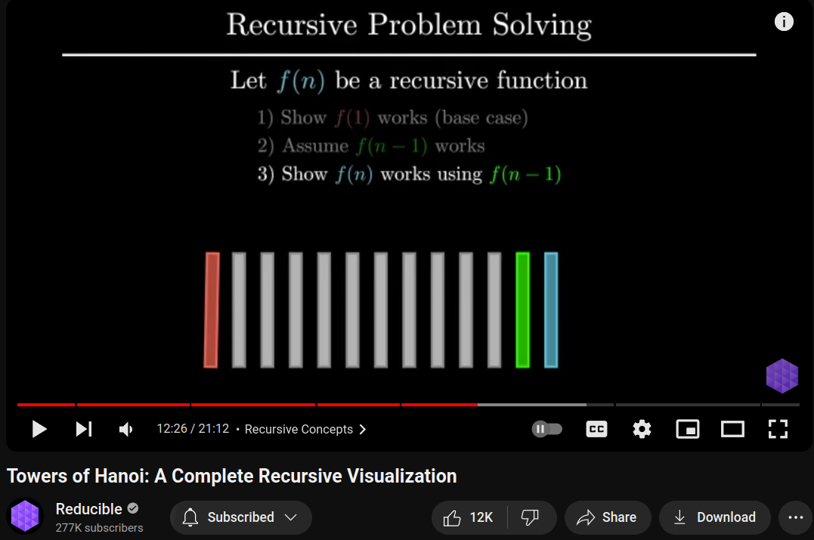

#include <stdio.h>

#include <bits/stdc++.h>

using namespace std;

#define ll long long int

void Print(int Start, int End){

cout<<Start<<" ---> "<<End<<endl;

}

void TowerOfHanoi(int n, int Start, int End){

if(n==1){

Print(Start, End);

}

else{

int Other = 6-(Start+End);

TowerOfHanoi(n-1, Start, Other);

Print(Start, End);

TowerOfHanoi(n-1, Other, End);

}

}

int main()

{

TowerOfHanoi(3,1,3);

return 0;

}